1. 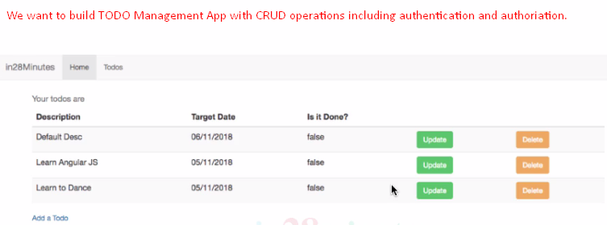
2. 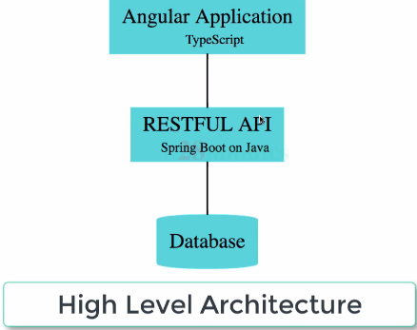
3. **What is Full Stack App**? It means we have a front-end app that talks to back-end API (Web Services).
4. 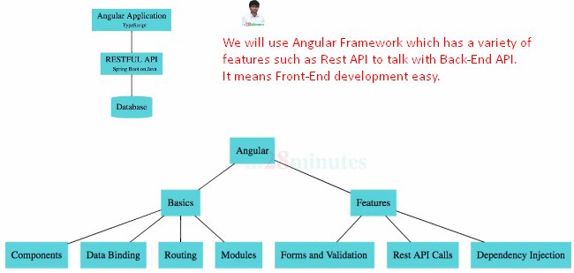
5. 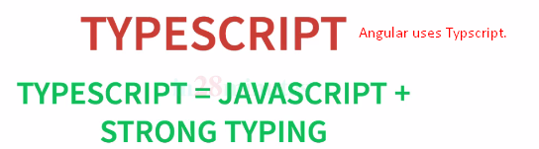
6. We will be using Spring Boot Framework to build RESTful API or Web Services. Spring Boot is no one framework to build RESTful API and Microservices.
7. We will multiple Web Services (for TODO Management APP and Authentication).
8.   
   As far as authentication is concern, we will start with basic authentication then JWT.  
   We will use Spring Boot to build authentication around the RESTful API.
9. Why do we make separate backend and frontend?
10. There are multiple complexities associated with building separate backend and frontend. For this we have understand multiple languages and multiple frameworks (Spring Boot & Angular).
11. The reason is to create a **flexible architecture** which can be extended to meet the future needs.   
    For example, in future you want to develop mobile apps in future or you want to connect with IOT (Internet of Things Devices), in such kinds of situations, you can completely reuse the backend APIs that is being exposed for Angular initially.